ME Awareness week 11-17 May 2015

WAMES invites you to join them to spread the word online about ME & CFS this year:

- Wear something blue (clothes, blue ribbon, wig etc)

- Write a sign explaining e.g. I’m wearing blue to raise awareness of ME & CFS

- Photo – take a selfie, holding the sign

- Post your selfie on your FB and twitter #BeMEaware. Include us @WAMESMECFS so that we can retweet your support

- Post on WAMES’ FB /WAMESMECFS, forums, blogs etc.

- Like WAMES FB and share it.
- Share the WAMES twibbon
http://twibbon.com/Support/spread-the-me-word-3

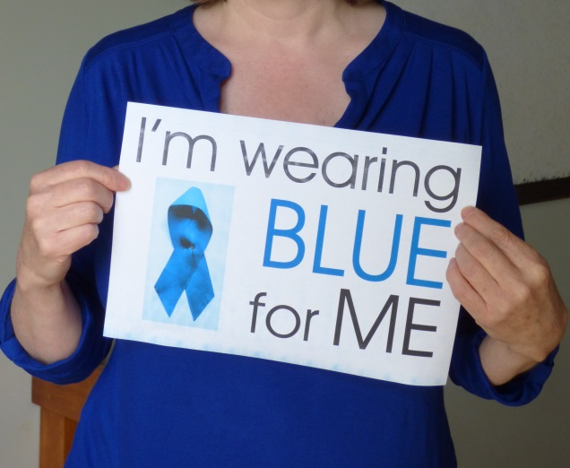

Key facts about ME in Wales:
- ME is classified as a neurological condition, and is a multisystem disorder.

- People can experience a wide range of debilitating symptoms, which can severely disrupt life, even causing them to become bed ridden.

- The key characteristic is a post-exertional response i.e. the body reacts abnormally to mental and physical activity, causing an increase in symptoms or serious relapse some days later.

- Over 12,000 people in Wales are thought to be affected.

- It is difficult to get an accurate, timely diagnosis and management advice.

- The Health Minister told Health Boards to develop services and a pathway in 2011.

- WAG formed a Task & Finish Group in 2013 to give specific guidance to Health Boards on how to start developing a pathway and services.

- During ME Awareness week 2015 WAG is launching an All Wales Implementation Group (with patient representation) to support Health Boards develop a pathway and services.

- Hywel Dda is the only Health Board with a specialist ME consultant and ME services action plan.

- The Welsh Association for ME & CFS Support (WAMES) provides information and campaigns for ME to be taken seriously. www.wames.org.uk helpline 029 2051 5061 helpline@wames.org.uk

