#TimeForUnrestWales
International ME Awareness Day – May 12th

Many of the estimated 12,600 families in Wales affected by ME and CFS are speaking out through a number of campaigns running during 2018:
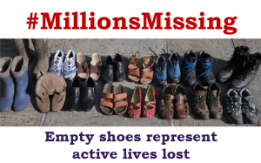
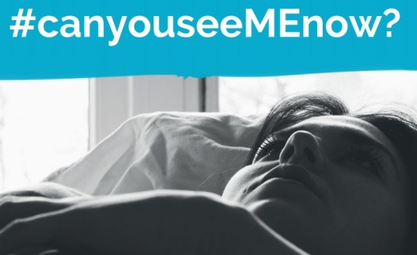

Global campaigns: #MillionsMissing #TimeForUnrest #CanYouSeeMEnow

Welsh campaigns: #TimeForUnrestWales #HelpNHSbeMEaware

#StopIgnoringME

There is a Health and Social Care crisis

for people with ME in Wales, starting with the struggle patients have to find an accurate diagnosis from doctors who understand ME.

The Welsh Government has had a plan
to change the difficulties patients have in accessing care since 2014 - the Task & Finish Group Report and Recommendations - but NHS Wales has failed to it seriously and little has changed.

Diagnosis is the first step
to all care and support (management advice, treatments, social care, education & employment adjustments, transport, benefits etc.) so…

WAMES is asking the Cabinet Secretary for Health to:
#HelpNHSbeMEaware and to provide, as a matter of urgency, support and finance for a national training and awareness programme.

#TimeForUnrestWales
is a campaign for health equality and the recognition of the neurological condition of ME.
Much work is needed to put ME & CFS on an equal basis with other neurological conditions!

Will you join us
by asking the Cabinet Secretary, Vaughan Gething, to take action and do what NHS Wales can’t or won’t do, i.e. give an accurate diagnosis to thousands of ill and desperate people? Read more: http://wames.org.uk/cms-english/2018/05/timeforunrestwales-the-struggle-to-get-an-accurate-diagnosis/

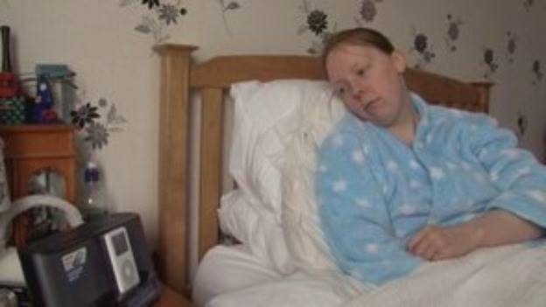
The situation in Wales in 2013 before the publication of the Task & Finish Group Report:
http://www.itv.com/news/wales/story/2013-05-13/me-care-recognition-lacking/ Michelle tells us nothing has changed for her and this claim has been echoed around Wales e.g.: http://memyselfrunning.blogspot.co.uk/2018/04/whats-up-doc.html?m=1
ME recognition and care is still lacking in 2018.

Welsh Association of ME & CFS Support www.wames.org.uk

