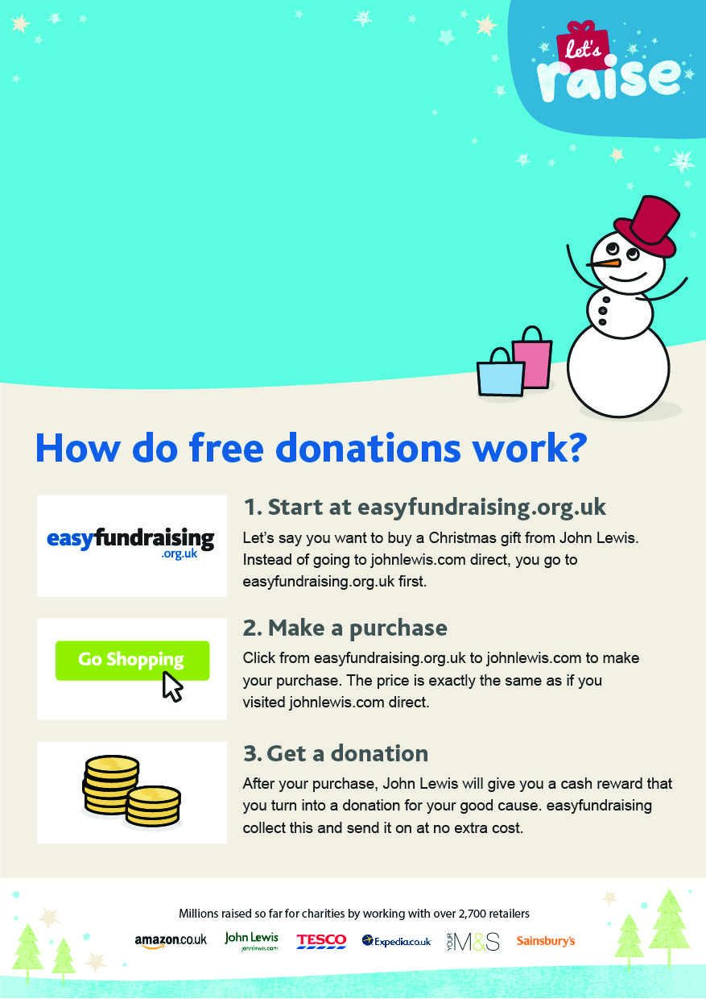­

Help WAMES raise free   
funds when you shop online!

Help WAMES raise free   
funds when you shop online!

Please support us at:

<http://www.easyfundraising.org.uk/causes/wames/>