

We promise to…

**Help us to develop a set of promises from The Welsh Ambulance Service to older people in Wales.**

At the Welsh Ambulance Services NHS Trust, we want to develop a list of promises to older people. This will be a list of things that we will promise you if you need to use any of our services.

We want to talk to older people about this and ask people what they would like to see in the list of promises. It is important to us to talk to you about this, so that you can tell us what you want. The comment form is on page 4.

**Why are we doing this?**

There are over 800,000 people in Wales aged 50+, over a quarter of our population. This will rise to over one million people in the next twenty years. We know that a large amount of older people use our services regularly, whether it be calling 999 or using our non emergency transport service for hospital appointments.

The rate of long term conditions, mobility issues and sensory impairments (including sight loss and hearing loss) generally increase with age. We want to make sure that the services we provide meet your individual needs and that you have a good experience when in our care.

**About us:**

We serve around 3 million people in all our communities across Wales. Our workforce consists of over 3,000 staff working in the following services:

* Emergency 999 Service
* Patient Care Services (planned transport for hospital appointments)
* NHS Direct Wales (telephone and online information / advice)
* Clinical Contact Centres (where we take the calls)

Find out more about us at [www.ambulance.wales.nhs.uk](http://www.ambulance.wales.nhs.uk).

**Our Purpose**

To be a caring and responsive ambulance service for people in Wales

**Our Vision**

A leading ambulance service providing the best possible care through a skilled, professional and healthy workforce.

**Our Behaviours**

* I will be kind, caring and compassionate
* I will ask and listen
* I will be honest and open with myself and others
* I will be my best, together we can be better
* I will own my decisions

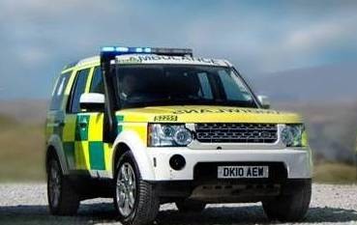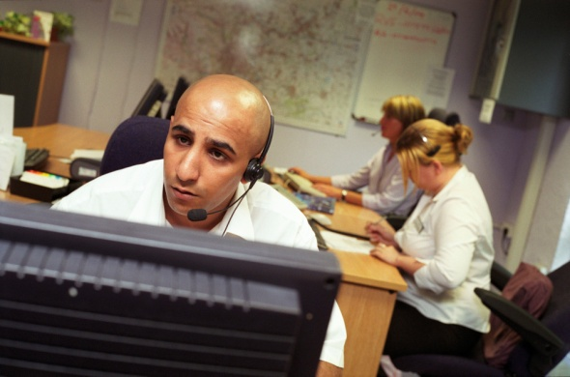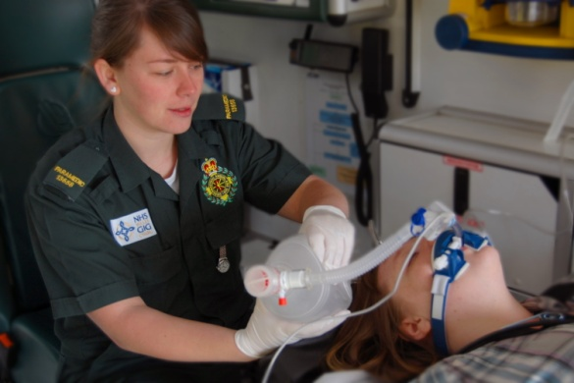**How to get involved?**

You can get involved by filling out the form on page 4, or by clicking [here](https://www.nhsdirect.wales.nhs.uk/fs/fs.aspx?surveyid=af111163c644b318f11f742962ad30f) to send us your comments online.

You can also invite us to your local Older People’s forum or group.

**We would like to have your comments by the 9th September 2016.**

Please return the form using this freepost address:

Freepost RTLS-UUHJ-GEZS

Welsh Ambulance Service

Conwy House, Castle Court

Phoenix Way

Swansea, SA7 9LA

**Email**: You can also email it to [ppi.team@wales.nhs.uk](mailto:ppi.team@wales.nhs.uk)

If you have any questions or would like help to complete the form, please telephone: 01792 311773

**What would you like us to promise you?**

You may want to think about:

* What is important to you if you were to use any of our services?
* What do you expect from us?
* How would you like to be treated?
* What is important to you if you are or have a carer?

Comment here:

1.

2.

3.

You can give us more if you like.

Any other comments

**Please return your comments by:** 9th September 2016

Thank you for completing this form.