Self-isolating with ME – Tell your story for ME Awareness week

We're hearing a lot about the joys and trials of being restricted to home when healthy or 'at risk'. Many people with ME are however practised at 'staying home' (or being housebound) while feeling very ill.

ME Awareness week, 10-17 May 2020

Help WAMES tell what self-isolation means for people with ME.

How does your ME self-isolation experience compare with the Covid-19 experience?

- the struggle to understand what was wrong with you
- grieving for your lost life
- learning to cope with new & frightening symptoms
- depending on others in new & unwelcome ways
- the uncertainty about recovery
- a changed relationship with your family and friends
- your contact, or lack of it, with the outside world
- how did you adapt & find a quality of life - hobbies, education, work

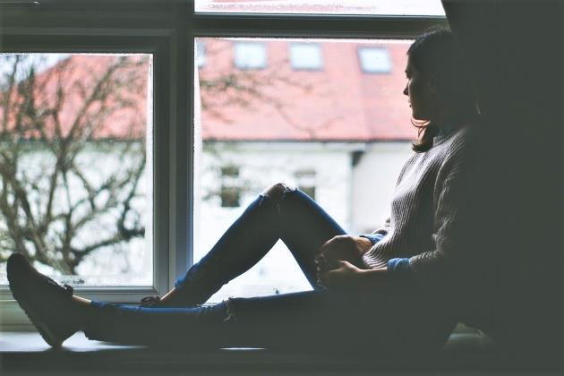
Isolated with ME – 2014-2017 View from my window - 2 years 2 months

How has the C-19 lockdown affected you?
- has it made life more difficult?
- brought back bad memories of being housebound in the past?
- has it opened up new experiences?
- is this your first experience of being housebound?
- is life less stressful or more lonely?
- have people understood your experience better?

Tell us
- in prose, rhyme, photos, or through the arts
- one paragraph or photo, or a longer story
- send as many contributions as you like
- in English or Welsh
- use your name or pseudonym
- give us your permission to use your contribution to raise awareness
- jan@wames.org.uk or helpline@wames.org.uk
- or via the online form www.wames.org.uk

There may never be a better time to communicate our experience.
So many people now know something of the frustrations of losing control of their future or have watched others suffer.

