WAMES Treasurer advertisement

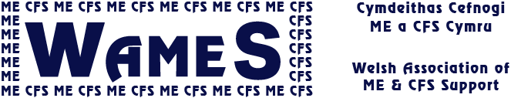

This role offers the opportunity to support the work of WAMES, the Welsh charity which represents and supports people affected by the neurological condition of ME, or CFS.

For those experiencing ME or CFS, carers and families – approximately 13,000 families in Wales - we provide vital support and information services which can enhance their quality of life. We also campaign to change attitudes and misunderstandings about the condition and improve services.

The role of the treasurer would be to:
- Maintain an overview of WAMES’ financial affairs and advise the committee on budgets
- Ensure that proper financial records and procedures are maintained

You would be based at home, but working with, and responsible to the management
Team, as a trustee of the organisation.

Main activities:
- Make payments, receive and record all money including fundraising and Gift Aid
- Record and monitor all Trustee and volunteer expenses
- Prepare the annual accounts and financial reports for committee, funders etc.
- Arrange an annual examination of accounts (if needed)
- Plan and review the budget with the Team
- Liaise with payroll service (if there are employees)
- Act as a joint signatory for cheques, invoices, contracts and other relevant documentation
- Share oversight of WAMES as a trustee (trustee insurance in place)
- Attend AGM and GM (possibly via Skype)

The opportunity may be available to share the role with another, if this can be arranged. WAMES is happy to discuss options.

Useful qualities and skills:
- Strategic vision and forward planning
- An eye for detail and methodical way of thinking
- Independent judgement
- Ability to work effectively as a member of a team
- Knowledge of the responsibilities of a trustee, or willingness to learn
- Knowledge of basic book keeping and financial management (as necessary)
- Knowledge of charity financial and fundraising practices, or willingness to learn
- The ability to analyse proposals and examine their financial consequences
- Knowledge and experience of current and fundraising finance practice relevant to registered charities.
Requirements:
✓Required to use own IT hardware but some software may be available
✓Age 18+

When?
Much of the work of the treasurer can be done at any time, though there will be occasional deadlines for reports and payments. It will be necessary to join occasional Skype team meetings at an agreed time.
Minimum hours expected per month: 2hrs, on average.
Minimum period of commitment: 3 years, as the handover period could take some months.

WAMES will:
- organise induction & suitable training
- pay agreed expenses

Process:
Selection procedures: ✓ Application form ✓ Informal interview
Selection details: Informal references may be required.

More information: www.wames.org.uk Jan Russell jan@wames.org.uk 01970 636515

June 2019

