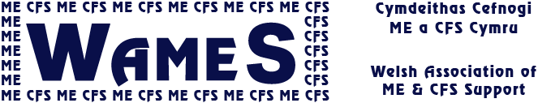

WAMES WordPress volunteer

This role offers the opportunity to support the work of WAMES, the Welsh charity which represents and supports people affected by the neurological condition of Myalgic Encephalomyelitis (ME) - sometimes called ME/CFS.

For those experiencing ME, their carers and families – approximately 13,000 families in Wales - we provide vital support and information services which can enhance their quality of life. We also campaign to change attitudes and misunderstandings about the condition and improve services. We expect the need for our support to increase as some people with long COVID can develop ME.

A WordPress volunteer would be involved with supporting and developing our 2 websites (Welsh and English) which also hosts a blog, poll and gallery.

You would be based at home, but working with, and responsible to the small Communications Team.

Activities could include one or more of the following:

- keeping content up to date
- troubleshoot technical issues
- help us to improve functionality to communicate more effectively about ME and WAMES to the relevant target communities in Wales (including young people and adults with ME, carers & family, professionals with an interest in ME)
- improve the design

Useful qualities and skills:
- knowledge of WordPress
- some experience of reviewing websites for functionality, usability, accessibility and performance, or a willingness to learn
- familiarity with a wide range of websites and blogs
- ability to work virtually with a team of volunteers who have varying levels of experience and health
- an eye for detail
- the role would be ideal for someone who needs experience of team working, or who wishes a career with IT in the 3rd sector.

Requirements:
✓Required to use own IT hardware but some help may be available
✓Age 16+

When?
Much of the work can be done at any time from home, though there will be occasional deadlines and meetings. Meeting dates will be arranged to suit all concerned.

Minimum hours expected per month: 8hrs, on average.
Minimum period of commitment: 6 months.

WAMES will:
- organise induction & suitable training
- pay agreed expenses

Process:
Selection procedures: ✓ Application form ✓ Informal interview
Selection details: ✓ Informal references will be required

More information: www.wames.org.uk sharon@wames.org.uk

June 2021

