WAMES Fundraising Volunteers Needed

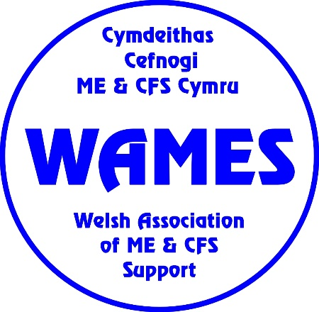
WAMES is offering opportunities to support the work of the charity which represents and supports people affected by the neurological conditions of ME and CFS, and post-viral illnesses in Wales.

13,000 – 14,000 families in Wales are affected by such conditions and this number is growing, as a significant number of people with long COVID can develop ME. We provide vital support and information services which can enhance quality of life. We also campaign to change attitudes and misunderstandings about these conditions and to improve services.

WAMES needs funds in order to be able to continue our vital work. Can you help?

WAMES is looking for people with a range of skills and interests to help us develop and adapt our fundraising strategy in line with the current economic climate. Volunteers would be based at home anywhere in Wales, working remotely, but working with the Finance and Communications Teams.

We need volunteers to help:
- Plan and coordinate fundraising campaigns
- Expand our ability to reach people through social media
- Identify novel and ‘free’ ways of getting funding
- Interest businesses in corporate fundraising
- Develop eye catching online events
- Research funding options and write grant applications
- Find local and national fundraising opportunities
- Develop a long-term sustainable fundraising strategy

Useful qualities and skills:
- Enthusiasm and a desire to make a difference
- A professional and friendly telephone manner
- Good written and verbal communication skills
- Ability to work on own initiative
- Commitment to work in compliance with policies and procedures
- Ability to work effectively as a member of a team
- Previous fundraising experience would be a bonus

Requirements:
✓Required to use own IT hardware but some software may be available on loan
✓Age 16+
✓6 month minimum commitment

WAMES will:
- organise induction, suitable training and support
- pay agreed expenses

Process:
Selection procedures: ✓ Application form ✓ Informal interview
Selection details: Informal references may be required.

More information: www.wames.org.uk or contact sharon@wames.org.uk

June 2022

